**Setting Up Tailwind CSS­ and Creating a Card Layout**

**Objective**

* Integrate Tailwind CSS via CDN.
* Create a responsive card layout using Tailwind CSS classes.
* Utilize CSS custom properties for styling.
* Use the provided image as a design reference.

**Instructions**

**Part 1: Setting Up Tailwind CSS via CDN**

1. **Create Your HTML File**
   * Create an index.html file.
2. **Include Tailwind CSS**
   * Add the Tailwind CSS CDN link in the <head> of your HTML file:

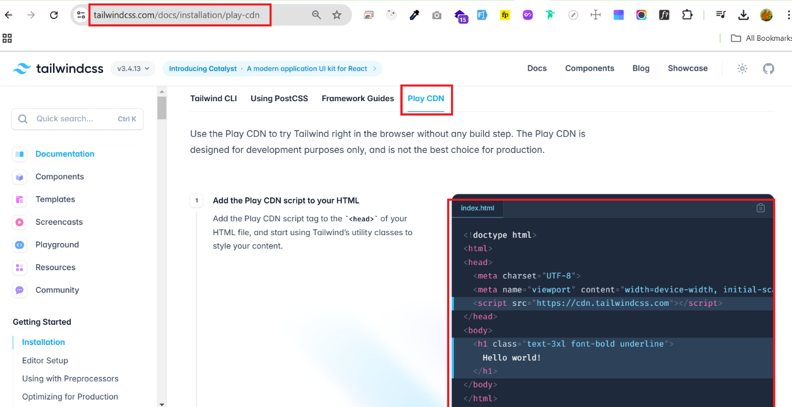

**Part 2: Creating a Card Layout**

1. **HTML Structure for Card**
   * Add the following card structure inside the <body>:

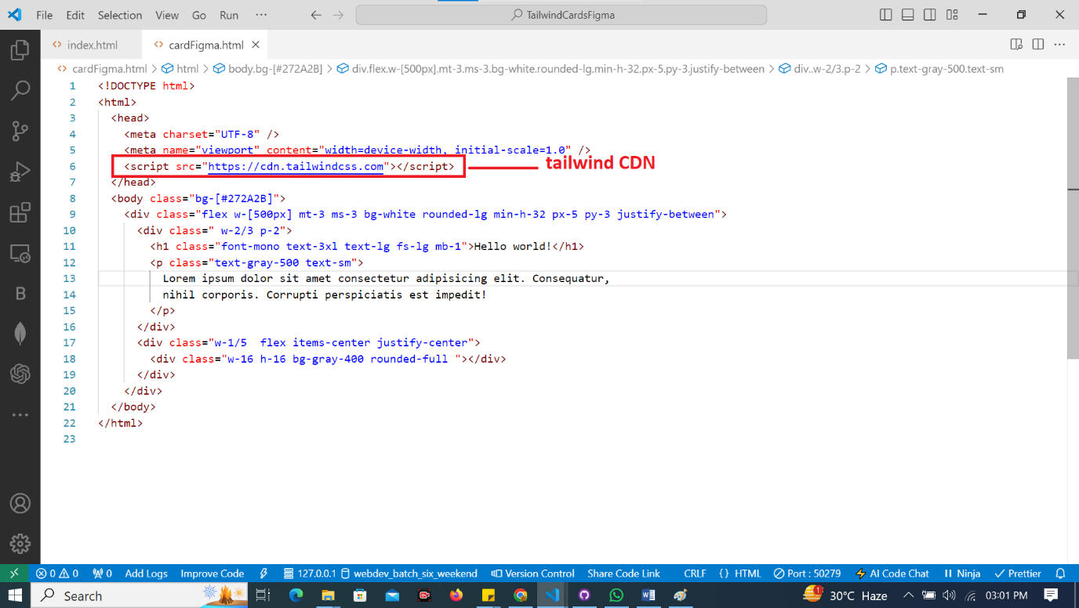

1. **Output**
   * The output of the card will be given as below:

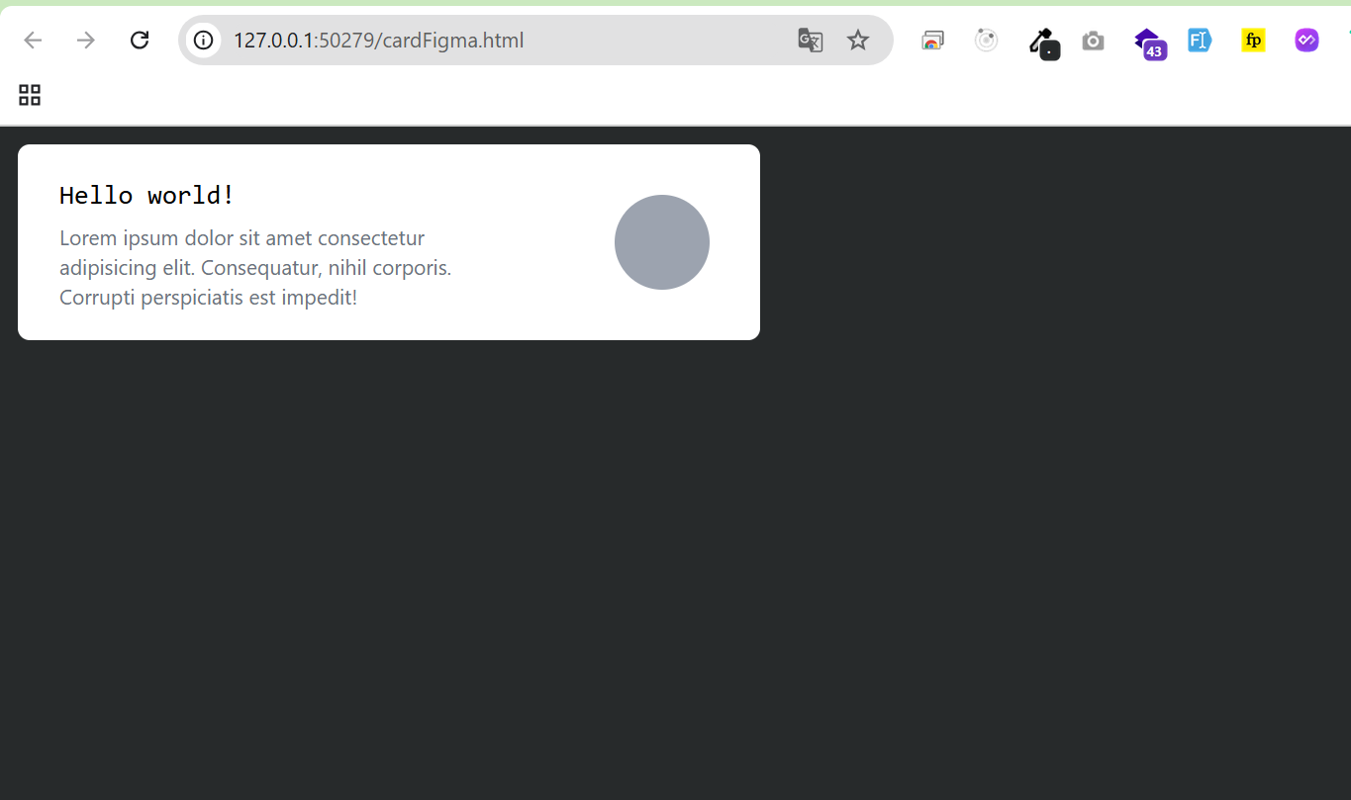

**Deliverables**

* A functional HTML page with Tailwind CSS integrated via CDN.
* A card layout styled using Tailwind CSS classes.